CS316

-Project 2 Report-

1. Element selector

Element selector selects all instances of a given element of HTML

An element selector in our css style sheet is called ‘html’. This affects all elements within <html> </html>.It makes all letters regardless of their size reduced to 50.5% based on their original size.

Element selector applied to give all elements in html document a font-size 50.5% regardless of their original side

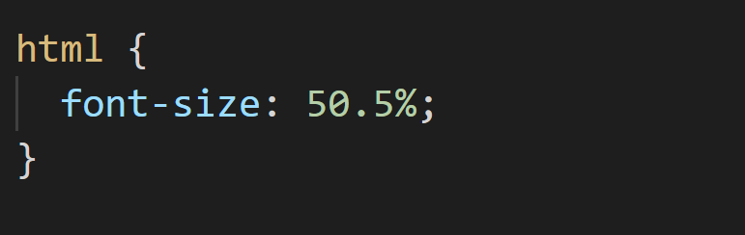

Element selector applied to style table

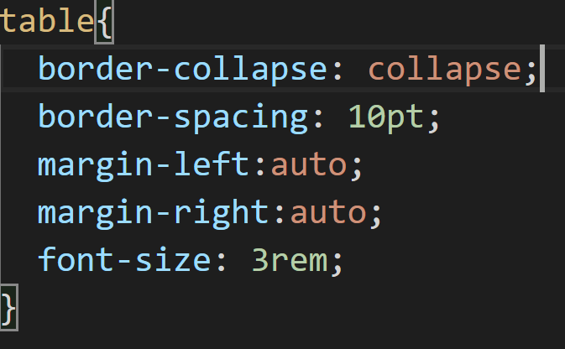

1. Class selector

All elements with the same class share the same attribute of the class regardless of their position. To declare a class selector, add ‘.’ in front of the class name.

Our class selector is .navBar. It styles all elements in the navigation bar including ‘Shop’, ‘About Us’, ‘Contact’, ‘Blog’, ‘Cart’.

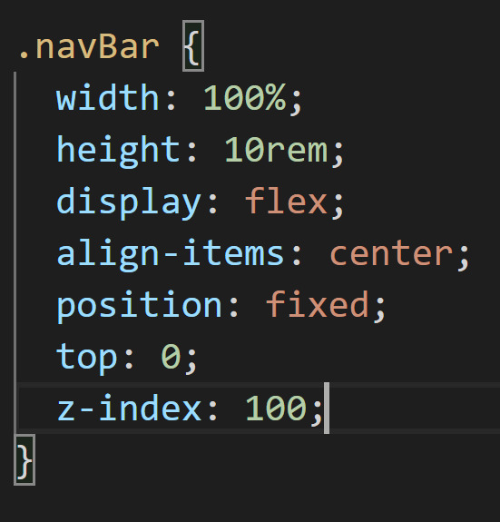

Class selector applied to style individual product card in product display

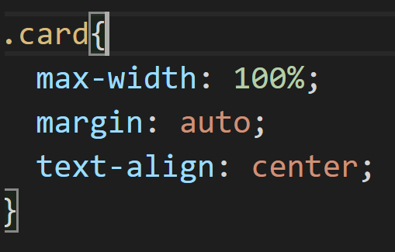

Webpage where the CSS rule apply:



HTML code CSS rules affect

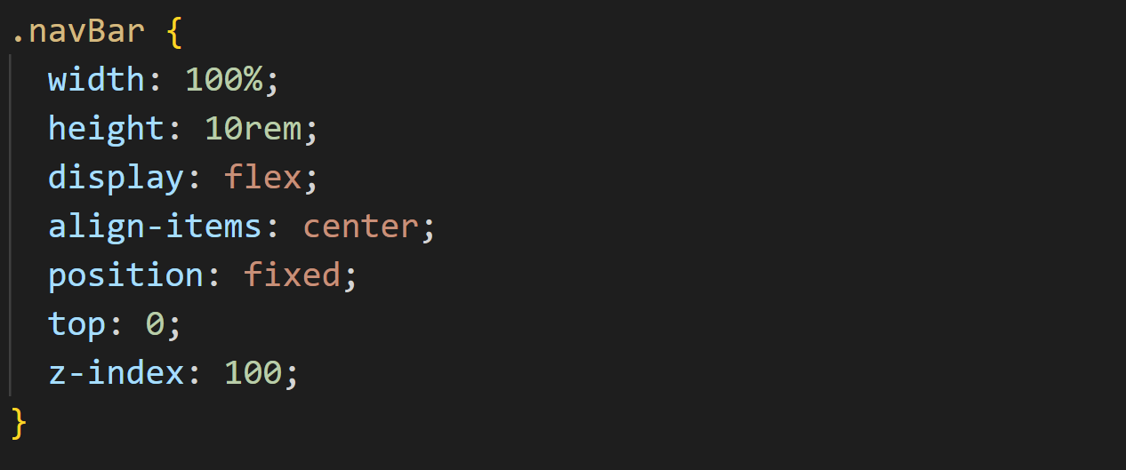

Webpage where CSS rules apply:



1. Id selector

ID selector is used to target a specific element within the HTML page so it is unique to just one element regardless of its type or position. Add a “#” in front of an ID name to create an ID selector.

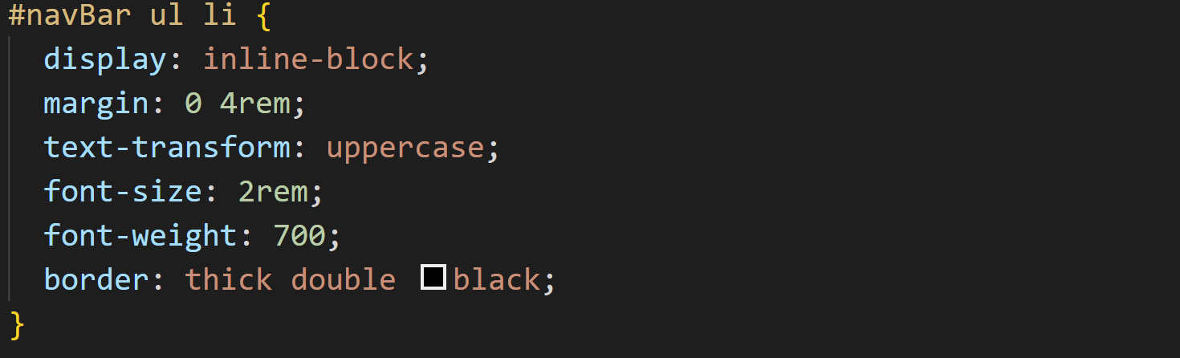

HTML code applied:

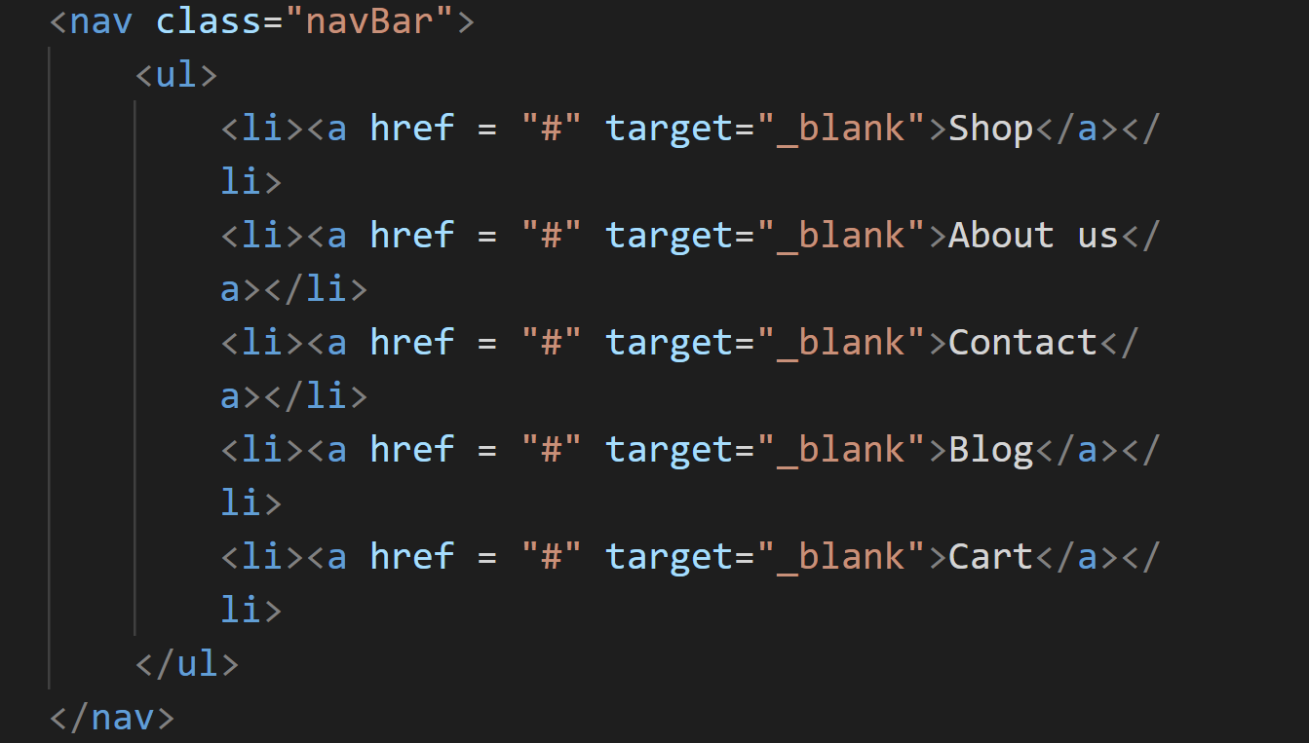

The webpage that CSS rules apply:



1. Pseudo class for links and hover

:hover pseudo-class: keyword added to the element to specify a specific state of an element. For example, when there is a pointer hovering over it.

Html:

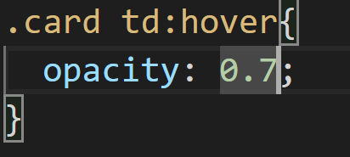 

Result of pseudo-class on the webpage

1. Use the box model to specify margins, padding, width, and height of some elements of your page



* The width and height of navBar block elements are adjusted.

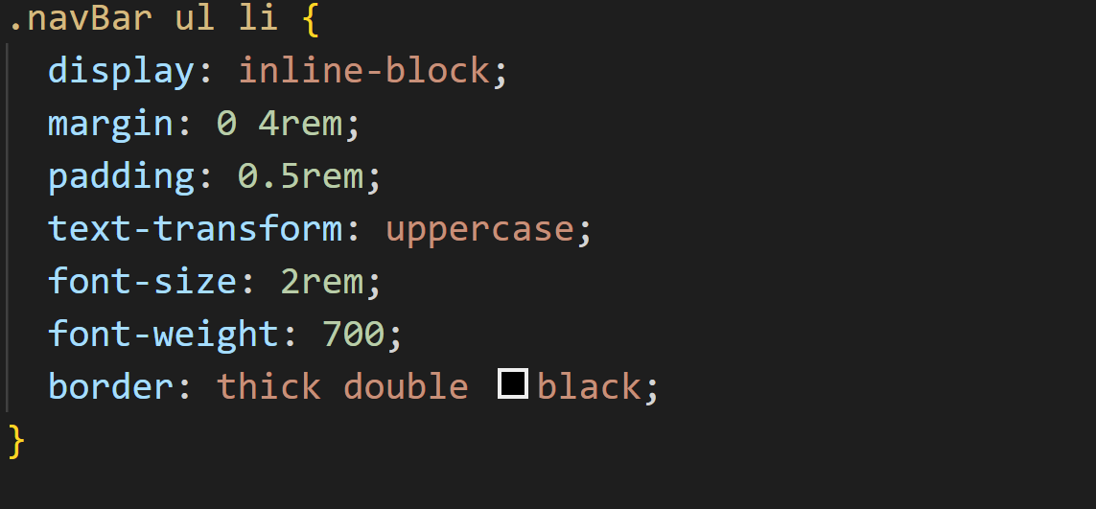

HTML code where CSS rule is applied:



Web page that affects by CSS rule:



1. Background image:

* Background-image: sets one or more background images on an element.

CSS rule:

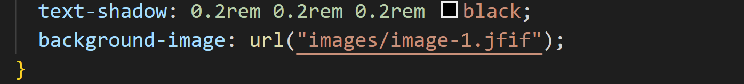

HTML Code:

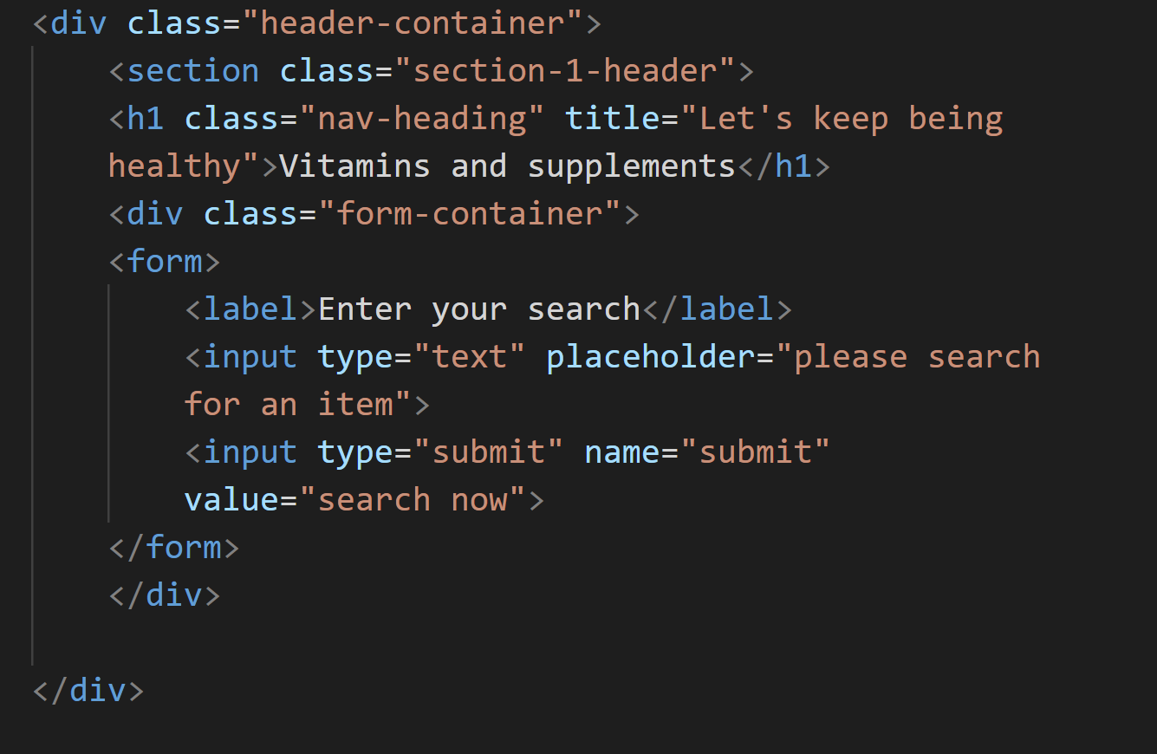

A webpage that affects by CSS rule:



1. CSS text styling

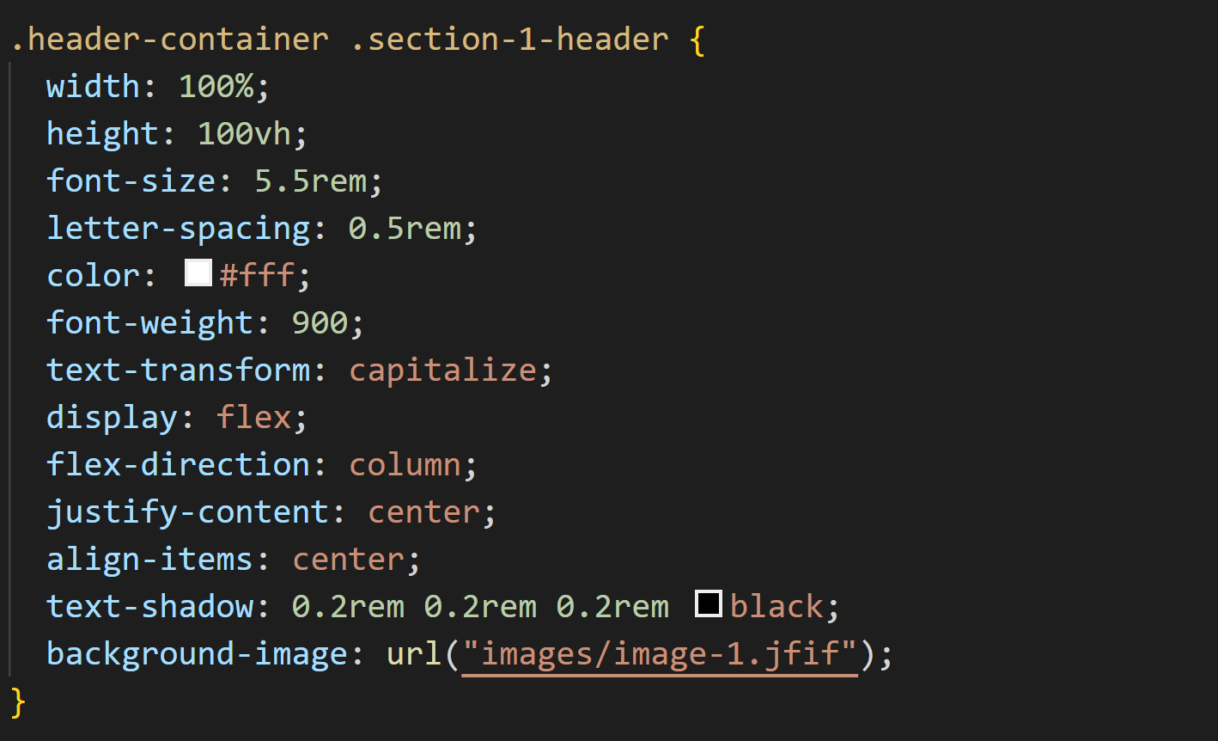

Text-shadow property and text-transform is applied

Text-shadow: add shadow to the text

Text-transform: specifies how to capitalize an element's text. It can be used to make text appear in all-uppercase or all-lowercase, or with each word capitalized. It also can help improve legibility for ruby.

HTML code where CSS rule is applied:



Webpage that is affected by CSS rule